Session 2 - 1

import java.io.BufferedReader;
import java.io.IOException;
import java.io.InputStreamReader;
import java.util.StringTokenizer;

public class Solution {

public static int[] maxSubarray(int[] arr) {
// 1. Maximum Subarray Sum (Kadane's Algorithm)
int maxSubarray = arr[0];
int currentSubarray = arr[0];

// 2. Maximum Subsequence Sum
int maxSubsequence = 0;
int maxElement = arr[0];
boolean hasPositive = false;

if (arr[0] > 0) {
maxSubsequence += arr[0];
hasPositive = true;
}

for (int i = 1; i < arr.length; i++) {
int num = arr[i];

// Kadane's calculation
currentSubarray = Math.max(num, currentSubarray + num);
maxSubarray = Math.max(maxSubarray, currentSubarray);

// Subsequence calculation
if (num > 0) {
maxSubsequence += num;
hasPositive = true;
}
if (num > maxElement) {
maxElement = num;
}
}

// If there are no positive numbers, the max subsequence is the largest negative/zero element
if (!hasPositive) {
maxSubsequence = maxElement;
}

return new int[]{maxSubarray, maxSubsequence};
}

public static void main(String[] args) throws IOException {
BufferedReader br = new BufferedReader(new InputStreamReader(System.in));
StringTokenizer st;

// Read number of test cases
String tLine = br.readLine();
if (tLine == null) return;
int t = Integer.parseInt(tLine.trim());

while (t-- > 0) {
// Read size of the array
int n = Integer.parseInt(br.readLine().trim());
int[] arr = new int[n];

// Read array elements
st = new StringTokenizer(br.readLine());
for (int i = 0; i < n; i++) {
arr[i] = Integer.parseInt(st.nextToken());
}

// Compute and print results
int[] result = maxSubarray(arr);
System.out.println(result[0] + " " + result[1]);
}
}
}

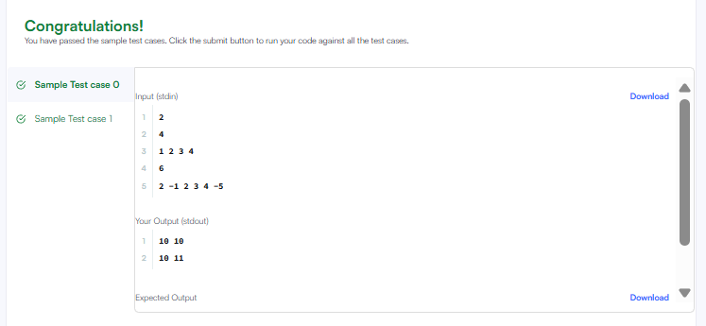

Session 2 - 2

class Solution {
public int maxSubarraySumCircular(int[] nums) {
int totalSum = 0;

// Track variables for standard Kadane's (Max Subarray)
int maxLinearSum = nums[0];
int currentMax = nums[0];

// Track variables for inverted Kadane's (Min Subarray)
int minLinearSum = nums[0];
int currentMin = nums[0];

totalSum += nums[0];

for (int i = 1; i < nums.length; i++) {
int num = nums[i];
totalSum += num;

// Standard Kadane's for Maximum Subarray
currentMax = Math.max(num, currentMax + num);
maxLinearSum = Math.max(maxLinearSum, currentMax);

// Inverted Kadane's for Minimum Subarray
currentMin = Math.min(num, currentMin + num);
minLinearSum = Math.min(minLinearSum, currentMin);
}

// Edge Case: If all numbers are negative, maxLinearSum will be the maximum element.
// totalSum - minLinearSum would incorrectly yield 0 (empty subarray).
if (maxLinearSum < 0) {
return maxLinearSum;
}

// Return the larger of the non-wrapping vs wrapping configurations
return Math.max(maxLinearSum, totalSum - minLinearSum);
}
}

